Small Group Questions:
- What is one thing that stood out to you from the sermon?
- What has been your experience with prayer? Does prayer come easily or naturally for you? How has your prayer life changed over time (if at all)?
- What is your excuse of choice for not praying? What practices might help you overcome that barrier?
- Kory said that it’s critical that we know the God we pray to. Do you agree? Why or why not?
- Why do you think how we live (and our attitude) has such a big impact on whether God listens to our prayers?
- What practical steps will you take to make prayer a greater priority in your life? (both during this Focus Season and beyond)
- Share your goals for prayer this year. What are you hoping to get from this study or from your prayer life?

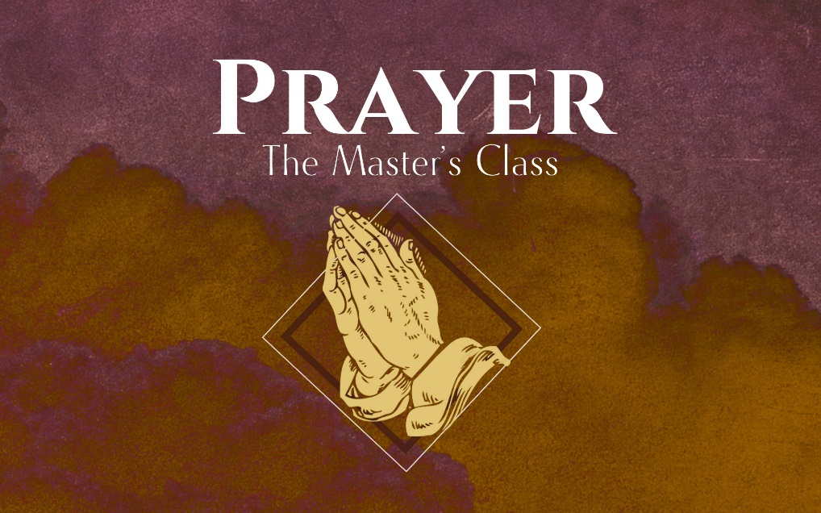

How to Pray

Our Father in heaven,
hallowed be your name,
your kingdom come,
your will be done,
on earth as it is in heaven.
Give us today our daily bread.
And forgive us our debts,
as we also have forgiven our debtors.
And lead us not into temptation,
but deliver us from the evil one.’
“For yours is the Kingdom and the Power and the Glory forever. Amen

What we believe about prayer will determine how we pray.

- A good-luck ___________.
- A spiritual _______________ machine.
- A __________________ technique.
- A last ________________.

“Prayer reorients me to see my smallness and acknowledge my utter dependence on God and it reminds me that God sees me and cares about me.”

It’s _______________ for us to know the God we’re praying to.

God is our gracious heavenly _____________ who happens to be the _______________ of the universe.

How to Pray:

- Choose a good __________ and _______________.

Our excuses:

- I’m too _____________.

- “These ___________!”

- I can’t ___________________.

- Do what helps you _____________.

Ideas:

- Start with _____________ ____________.
- ______________ while you pray.
- Pray out ____________.
- _____________ your prayers.
- Develop an ___________________ life.

- Pay more attention to your _____________ than your _____________.

There are no Christian “magic words.”

- Matthew 6:7-8
- Romans 8:26-27

The attitude of your heart can hinder your prayers.
- Matthew 6:14
- Psalm 66:18
- James 4:3
- Proverbs 21:13
- Psalm 51:17

