Questions for Small Groups:
- How has your daily practice been going? Have you gained any valuable insights about prayer?
- What stood out to you most about the message?
- Why is it important for us to recognize that we are not perfect just the way we are? How can this be good news?
- How seriously do you take sin in your own life? Are you more prone to obsessing over sin or excusing (or psychologizing) sin and taking it too lightly?
- Which of the four types of sin Kory mentioned are you most prone to commit? How might you overcome these?
- Why do you think Jesus makes our willingness to forgive a condition of our own forgiveness?
- Tell your small group about an experience that you’ve had either forgiving someone or asking forgiveness from someone.

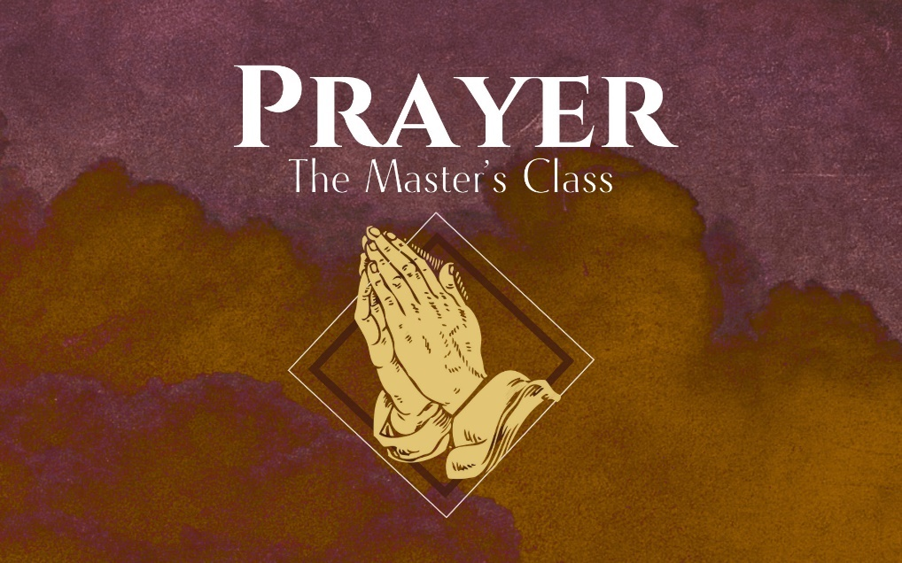

Forgive Us Our Debts

Our Father in heaven,
hallowed be your name,
your kingdom come,
your will be done,
on earth as it is in heaven.
Give us today our daily bread.
And forgive us our debts,
as we also have forgiven our debtors.
And lead us not into temptation,
but deliver us from the evil one.’
“For yours is the Kingdom and the Power and the Glory forever. Amen

Since Sigmond Freud, we now live in the ________________ world.
The Good:
- It genuinely aims to ___________ people.
- It recognizes that our bad behaviors have deeper ___________.

“Sin is an illegitimate way to meet a legitimate need.”
- John Ortberg

The Problem:
Our thoughts, feelings and desires become the _______________ by which all actions are judged.

“The heart is deceitful above all things. Who can understand it?”
- Jeremiah 17:9

The therapeutic world does not tell us the ______________!

Jesus’ two critical truths:
- You are not ____________ just the way you are.
- God ___________ you anyway!

“Forgive us our debts as we forgive our debtors.”

Two Requirements for forgiveness:

- ________________ (1 John 1:8-9, Luke 18:9)

What should we confess?
- Sins of _________________
- Sins of _________________
- Sins of _________________
- Sins of _________________

- We must ________________ others. (Mt 6:14-15, 18:21-35)

Would you like God to apply the same level of forgiveness you give to others?

We are all both _____________ and _______________ of sin.

_____________ ___________ sin does not have the power to keep you stuck unless you give it to them.

Forgiveness:
- IS letting go of anger, resentment, and the desire to _________________ for a wrong done to you.
- Is NOT __________________
- Is NOT _______________
- Does not make ____________ of wrongdoing.

The goal of confession is not to make us feel _______________, but to make us _______________ for how good God is.

