Questions for Group or Personal Reflection:
- What stood out to you most about the message?
- Have you ever considered attempts at utopia to be attempts to earn our salvation? Do you think this is true?
- Why have human attempts at utopia (salvation) always ended in dystopia? (Give some examples.)
- Why do we need good news rather than good advice?
- Why does it matter that we understand that we won’t experience utopia fully until eternity? How might this impact how we live right now?
- In the message, Kory said Jesus saves us by:
  - Representing us
  - Restoring the image of God in us
  - Paying our debts
  - Dying and rising again (proving his kingship)
  - Giving us his Spirit

How are each these good news for you?

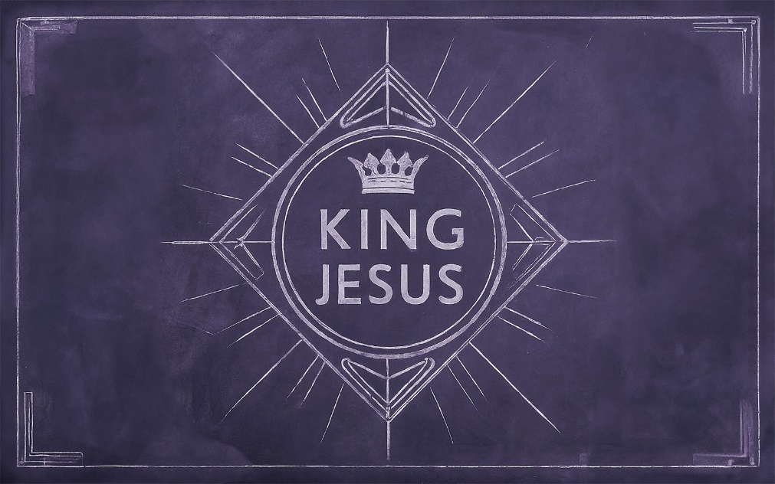

Saving King

_________________ = “a good place”

_________________ = a place that doesn’t exist

All ideas about utopia have two things in common:
- They believe it can be achieved by _____________ effort.

- They have all ended in _______________.

All human efforts to bring about utopia lead to _______________.

The problem with ideologies is that they _____________________ the problem.

The Bible tells us the real problem is something called __________.

Genesis 1 & 2 describe a utopia of sorts.

Two Trees:
The Tree of _______________.

The Tree of the Knowledge of ___________ (towb) and ______________ (ra).

The human dilemma: “Do I get to be the ___________ who determines right and wrong, good and bad, or do I leave that to the real ____________?”

Ever since Adam and Eve’s sin, we see the same pattern: people exchanging their God-given purpose to build our own _________________.

As a result, the world is _______________ ________.

To fix it, we don’t need ____________ _____________, we need ____________ ____________.

The good news? _____________ is _____________!

King Jesus saves us by…

…_____________________ us.

…_____________ the Image of God in us.

…paying our _____________.

…._____________ and ___________ again.

…giving us his ______________.

The world will not be fully ___________ until the King returns.

True Utopia:
- The return of the Tree of Life.
- The lifting of the curse.
- The reign of God with his people forever.

