Questions for Group or Personal Reflection:
- What stood out to you most about the message?
- What makes it so difficult for us to be humble and value others’ needs ahead of our own?
- Settle the debate: Do you think Jesus is humble “because” he ss God or “despite the fact that” he is God?
- In what ways to do try to manage your image?
- Why do you think God chose the downward path for Jesus to become king rather than just coming in power?
- How does admitting both that we are God’s image-bearers and that we don’t reflect Jesus perfectly, free us to not need to prove anything? How well do you feel you live this out?
- How might you learn to truly embrace what God says is true about you? How would this free you to better serve others?

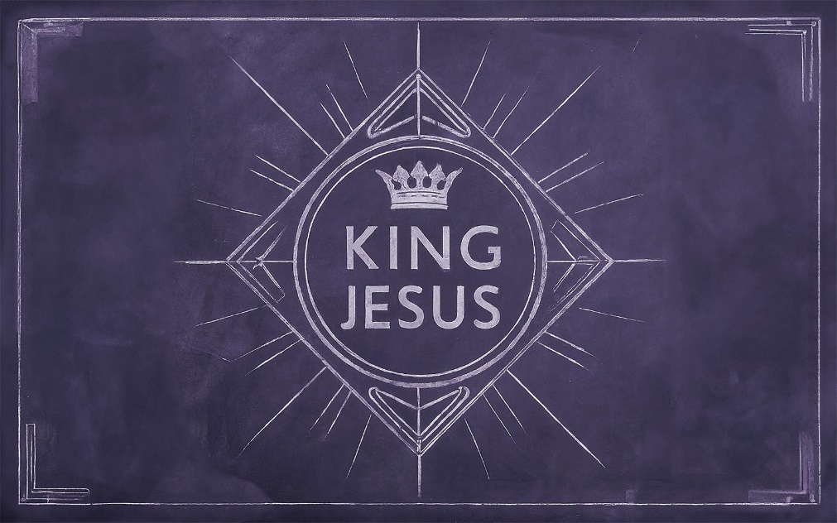

Humble King

The people in the outlying areas believed Jesus was the anointed ______________ of _____________.

But the scene would have been _______________ because he rode a donkey.
- Donkeys signaled _____________, not __________.

Our world continually urges us to build our own kingdom because we _______________ it.
Our personal kingdom-building only leads to _________________ __________________.
Scripture: Philippians 2:1-11
Most scholars believe verses 6-11 are an early Christian ______________.

Jesus was “in very nature, ___________.” (vs 6)
- John 1:1-3
- Colossians 1:15-16

“He did not consider equality with God something to be used to his own ____________________.”
- We are all experts at _____________ management.
- We want people to see that we are _________________.

Because Jesus knew he was God he didn’t need to _____________ anything to himself.

Humility always begins with confidence in our standing as God’s ___________-______________.

“He made himself nothing, by taking the very nature of a servant, being made in human likeness…” (vs 7)
- To be great in Jesus’ kingdom, we must climb ____________ the ladder.
“and being found in appearance as a man, he humbled himself, becoming obedient to death, even death on a cross.” (vs 8)
- On his journey down, he kept his eyes _________.

The path to greatness in Jesus’ kingdom is the __________________ path.

“Therefore, God exalted him to the highest place…” (vs 9)
- Jesus came to be installed as our _____________.

We are called to ________________ the character of our King.

The key to humility is ___________-esteem
You are a creature made in __________ image…but you don’t _____________________ that perfectly.

Because we are children of the king, we have nothing to ___________.

