Questions for Group or Personal Reflection:
- What stood out to you most about the message?
- Have you ever thought about the teachings of Jesus as part of “the Gospel” of Jesus? Why are the teachings of Jesus good news?
- Do you think Jesus’ teachings in the Sermon on the Mount are for wise living in this world?
- Do you believe Jesus intended people who are not his followers to follow the Sermon on the Mount? Why or why not?
- Which of the five teachings for living in the Kingdom is easiest for you follow?
  - Upside-down
  - Inside-out
  - Above and beyond
  - Before everything else
  - In the doing
- Which is most challenging?
- In what areas do you need most to grow in the wisdom of the Kingdom?

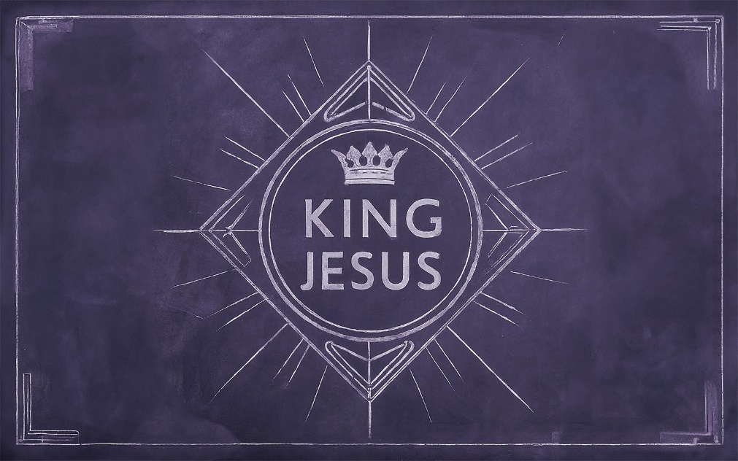

Wise King

The Gospel is good news (but it also contains good ____________.)

The call to seek _______________ is all over the pages of the Bible.
- Proverbs 1:2
- Proverbs 9:10

Wisdom is NOT…
…the same as _______________.
…common _______________.
…a life-______________.
…whatever ____________.

What Wisdom IS
The wisdom Jesus offers is wisdom for living in _______ _______________. (Ex 19:5, Deut 4:6, Mt 5:13-16)

The wisdom of the Kingdom is __________-___________.
- Matthew 5:3-12
- Matthew 20:20-28
- Luke 1:51-53

The wisdom of the Kingdom is ____________-_________.
- Matthew 5:20-37
Jesus calls us to live a life of ___________ for God and others from the inside out.

The wisdom of the Kingdom is __________ and ____________.
- Matthew 5:43-48
God wants the best, even for his ______________.

The wisdom of the Kingdom comes _____________ everything else.
- Matthew 6:19-34
The attitude that changes everything: the king of the universe sees us, knows us and ____________ about us.

The wisdom of the Kingdom is proven in the _____________.
- Matthew 7:24-26

Too often we are educated beyond our ability to __________.
True wisdom is wise ______________.

Reflect:
In what areas does your life exhibit the wisdom of Jesus?
What areas of your life do you need to submit to the wisdom of Jesus?

