Small Group Questions:
- How did your practice of praying the Lord’s Prayer go this week? Were you able to consistently set aside time for prayer? Did you gain any new insights?
- What stood out to you from the message?
- How does our concept of God impact how we pray? Can you give examples?
- Why is it important that we realize that we never just pray alone, but we pray “OUR father?” How might this change how you pray and what you pray for?
- Are you more prone to approach God as “daddy” or “the holy creator of the heavens and earth?” How might we find a healthy balance of comfort and confidence on the one hand and awe and reverence on the other?
- Gregory of Nyssa said: When in prayer I say “hallowed be thy name”; but what I seek is that these words may impact me. I ask that through your divine help you will make me pure, righteous, faithful, and that I may abstain from all evil, speak truth, and practice justice. I ask to walk along the straight path, illumined by temperance, adorned by incorruption, beautified by God’s virtue and wisdom.” What impact might remembering this make on how you pray?
- What might prayer for the unity and holiness of the church look like?

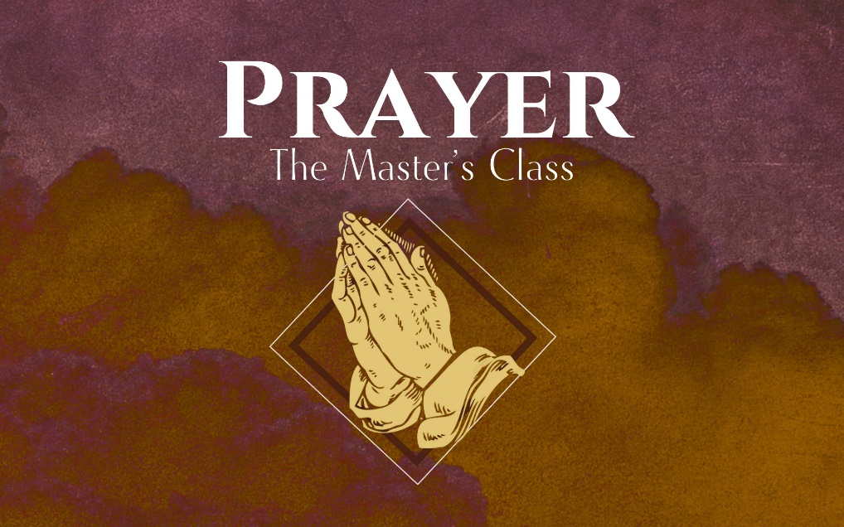

How to Pray

Our Father in heaven,
hallowed be your name,
your kingdom come,
your will be done,
on earth as it is in heaven.
Give us today our daily bread.
And forgive us our debts,
as we also have forgiven our debtors.
And lead us not into temptation,
but deliver us from the evil one.’
“For yours is the Kingdom and the Power and the Glory forever. Amen

What we believe about _________ will determine how we pray.

“OUR FATHER IN HEAVEN, HALLOWED BE YOUR NAME”

“_________”

- The faith of Jesus isn’t a _____________ faith.

- The whole prayer is __________________.

“______________ in ______________”
- God is both _________________ and __________________

Father:
- Jesus intentionally uses the language of _______________ to describe God.
- Jesus doesn’t mean God as “creator,” but in the sense that through him we are _______________ into God’s ____________.
- This doesn’t cause ____________, but ______________.

In heaven:
- God is not our _________________.
- Psalm 8
- “let us approach the throne of grace with confidence.” (Hebrews 4:16)
This means:

- We recognize the need to approach God with the ___________ due him.
- The purpose of prayer is not to ask God to do my _____________.
- Prayer is much ___________ and more _______________ than what we often pray for.

“_______________ be your name.”
- Prayer is an act of _______________.
- It is _________________ for us to pray that God’s name would be hallowed, but not strive to _______________ him well.

Takeaway:
- Prayer is _________________
- God is both ___________ and _________________.
- We pray that God would be ______________ in us.

