Questions for Personal Reflection:
- What has been the primary way you have thought about Jesus? (e.g. father, friend, healer, savior, lord, etc.?)
- Read the following passages, what do they say the gospel contains?
  - Mark 1:14-15
  - Luke 7:22-23
  - Acts 2:14-36, 5:42, 10:42, 13:32
  - 1 Corinthians 15:1-8
  - Romans 1:1-5
  - You can also search “gospel” in a concordance or Bible app to find other instances.

- What difference might it make if you began to view him as king?
- How is thinking about faith as “allegiance” different than thinking of it as strictly believing a set of propositions about Jesus?
- How is this gospel good news for you?

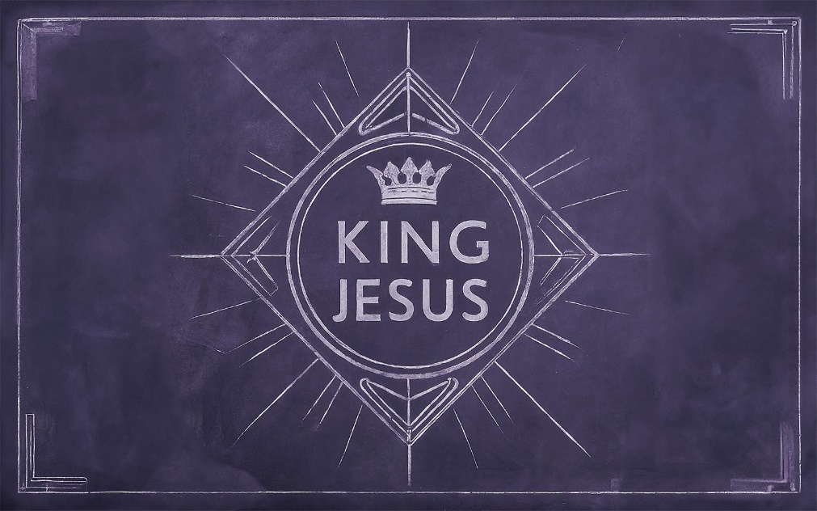

The Real Gospel

We have a name for good advice: ________________.

We have a name for good news: ________________.

What is the Gospel?
- “Jesus died for my sins so I can go to heaven.”

The Problem?
- It’s overly _____________________.
- Why is _________________ necessary?
- It misunderstands the Biblical word “____________.”
- It leaves out the ________________ and ________________ of Jesus.
- __________ didn’t preach this gospel.

What IS the Gospel?
“____________ is ____________”

Gospel: Greek = __________________ (evangelism)

- Mark 1:14-15
- 2 Timothy 2:8
- Acts 2

Jesus is referred to as ___________ 455 times.

Scripture: Romans 1:1-4

The Gospel in Scripture:
Jesus the king (Christ):
- existed before time as God the Son
- was sent by the Father
- took on human flesh in fulfillment of God’s promises to David
- died for our sins according to the Scriptures
- was buried, and raised again on the third day in accordance with the Scriptures
- appeared to many witnesses
- is enthroned at the right hand of God as the ruling Christ
- has sent the Holy Spirit to his people
- and will come again as final judge to rule

How is this Good News?
Jesus is not just the king over ____________, but also the king over ____________!

How should we respond?
The Gospel calls us to “the __________________ that comes from ______________.”

Faith=Greek: pistis:
- Believing a set of propositions
- A pledge to be __________________.

To be faithful to a king is to pledge ___________________ to his way of life.

