Questions for Small Groups:
- What stood out to you most about the message?
- Do you consider what is happening in the spiritual realm or do you tend to think more about the physical realm you can see in front of you? Why might that be?
- Consider the three weapons for spiritual battle Pastor Abby mentioned. Which of these do you tend to use most? Are there any you neglect? Do you think of them as weapons for spiritual battle? Why or why not?
- How might Jesus’ example of facing temptation in Matthew 4 impact how you might engage in spiritual battle?
- How might your small group change how it prays as a result of this message?

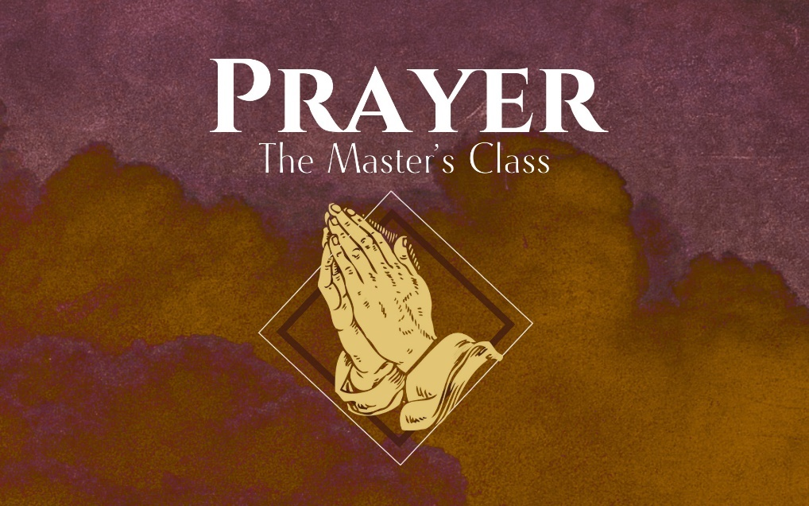

Deliver Us from Evil

Our Father in heaven,
hallowed be your name,
your kingdom come,
your will be done,
on earth as it is in heaven.
Give us today our daily bread.
And forgive us our debts,
as we also have forgiven our debtors.
And lead us not into temptation,
but deliver us from the evil one.’
“For yours is the Kingdom and the Power and the Glory forever. Amen

There is far more to this world than what we __________
with our __________.
- Colossians 1:13-14
- Romans 8:27-29
- Ephesians 6:12
- 2 Corinthians 10:3-5
What are the ___________________ we fight with?

- We rely on the power of the _______________
_______________.
- We use the weapons of:

  - _______________
  - _______________
  - _______________

What kind of battle are we in?

- “Our struggle is not against flesh and blood…”

Jesus’ Temptation in the Wilderness (Mt. 4)

- Turn stones into bread
- Jump from the highest point of the temple
- Bow down and worship the enemy in exchange for the kingdoms of the world

In every spiritual battle that Jesus faced, He relied not on human
_______________ or _______________, but on the truth of who God is.

We won’t always know the spiritual battle that is going on behind the scenes, but God does.

Our weapons are different and so are our methods.

- Exodus 14
- Joshua 7
- 2 Chronicles 20
- Judges 7
- Acts 12
- Acts 16

